Republic of the Philippines
Don Mariano Marcos Memorial State University
Mid-La Union Campus
City of San Fernando, La Union

In Partial Fulfillment
of the Requirements for the Course
IT 121 - Advanced Database Systems

by:
FIRSTNAME MI. LASTNAME
FIRSTNAME MI. LASTNAME
FIRSTNAME MI. LASTNAME
FIRSTNAME MI. LASTNAME
FIRSTNAME MI. LASTNAME

Project Description

The Bauang Agricultural Trade Center (BATC) Centralized Distribution and Allocation Management System is a role-based web application designed to digitize and streamline the agricultural aid distribution process of the Bauang Local Government Unit (LGU) in La Union, Philippines. The system operates across three distinct user roles - Administrator, Staff, and Client (Farmer) - each provided with a dedicated interface and set of responsibilities aligned to their function in the overall distribution workflow.

The Administrator holds the highest level of access in the system. Upon logging in, the Administrator can manage all user accounts, including creating, updating, and archiving Staff and Client accounts. The Administrator oversees the full lifecycle of agricultural aid programs by creating programs, defining eligibility criteria, managing inventory items and stock batches, scheduling distributions, and generating system-wide reports. The Administrator also manages farmer records and can make announcements to be broadcast to specific user groups or barangays.

The Staff user role is assigned to field personnel who assist in day-to-day operations. Staff members can register and update farmer profiles, process and review farmer applications for agricultural programs, update distribution statuses in the field, manage inventory movements, and respond to farmer feedback. Staff users operate within the bounds of programs and distributions created by the Administrator, ensuring accurate tracking of aid delivery from scheduling through completion.

The Client (Farmer) is the primary beneficiary of the system. Clients can log in to view available programs and submit applications for agricultural aid. They can monitor the status of their applications and scheduled distributions, view announcements relevant to their barangay or segment, and track the status of their aid distribution. Following distribution, Clients may submit feedback by providing a star rating (1-5), selecting an issue type, and leaving a comment, which Staff and Administrators can review and respond to.

Use Case Diagram

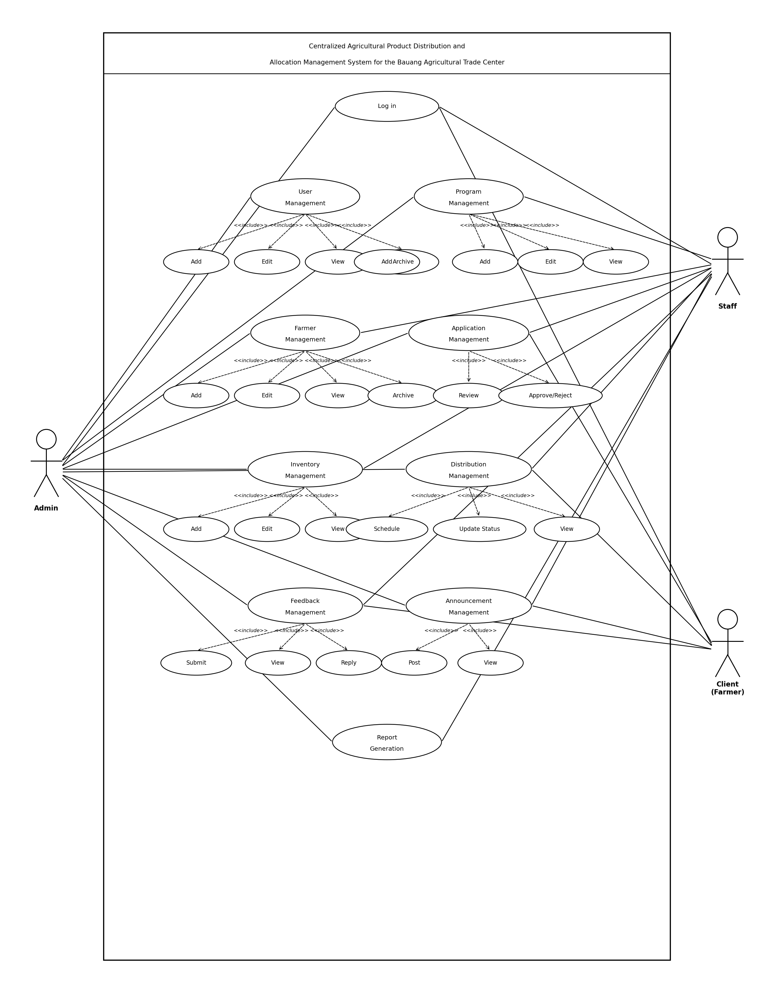

Entity Relationship Diagram

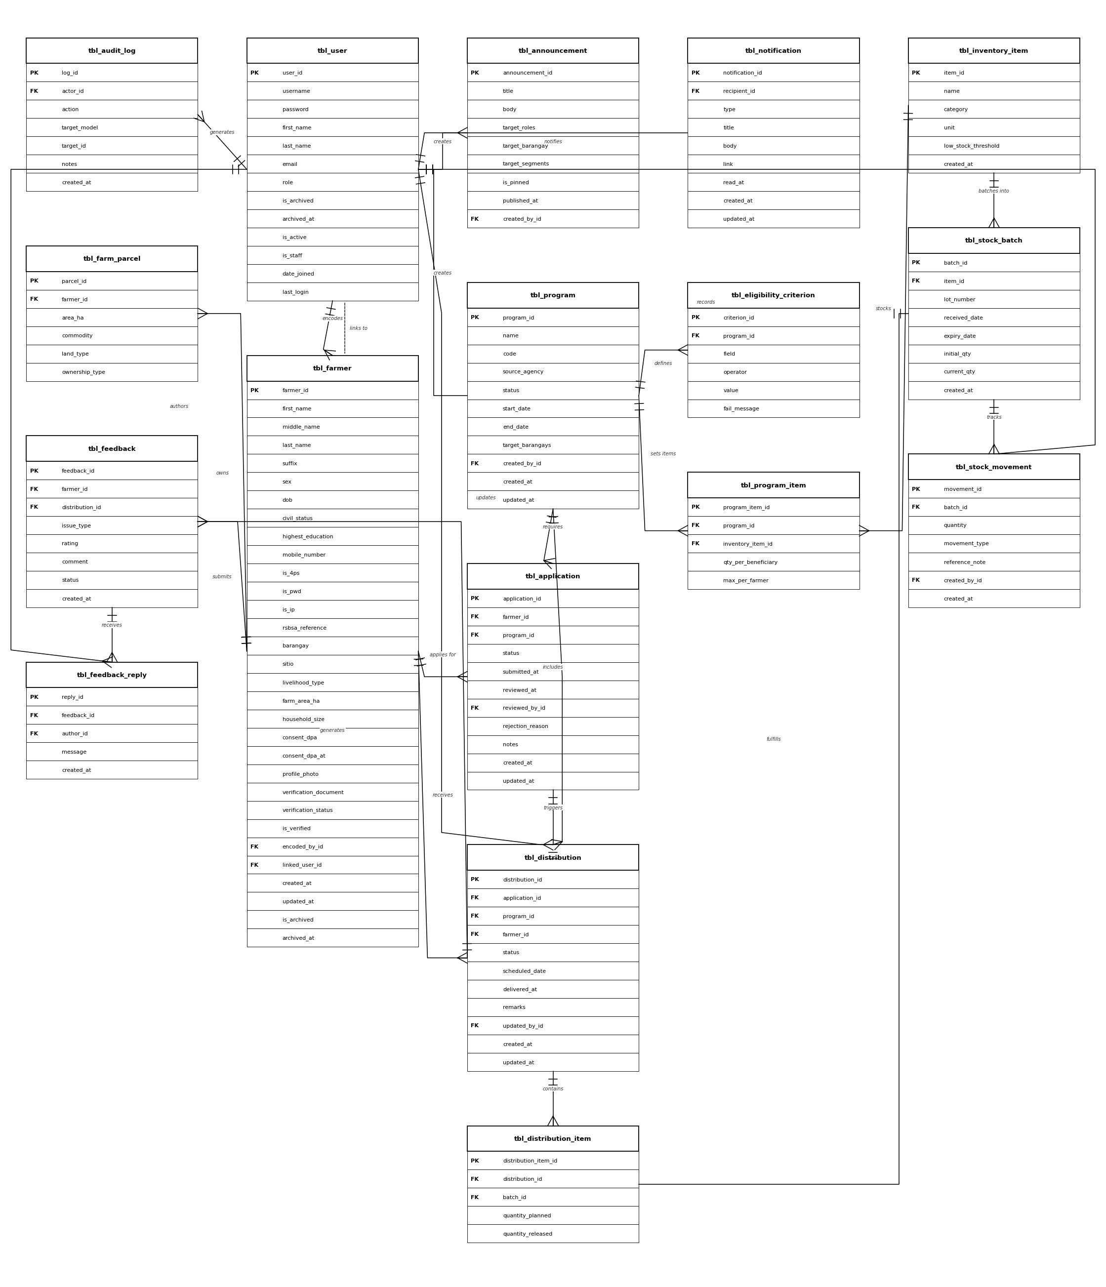

Relational Database Schema

tbl_announcement {announcement_id, title, body, target_roles, target_barangay, target_segments, is_pinned, published_at, created_by_id}
tbl_application {application_id, status, submitted_at, reviewed_at, rejection_reason, notes, created_at, updated_at, farmer_id, program_id, reviewed_by_id}
tbl_audit_log {log_id, action, target_model, target_id, notes, created_at, actor_id}
tbl_distribution {distribution_id, status, scheduled_date, delivered_at, remarks, created_at, updated_at, application_id, program_id, farmer_id, updated_by_id}
tbl_distribution_item {distribution_item_id, quantity_planned, quantity_released, distribution_id, batch_id}
tbl_eligibility_criterion {criterion_id, field, operator, value, fail_message, program_id}
tbl_farm_parcel {parcel_id, area_ha, commodity, land_type, ownership_type, farmer_id}
tbl_farmer {farmer_id, first_name, middle_name, last_name, suffix, sex, dob, civil_status, highest_education, mobile_number, is_4ps, is_pwd, is_ip, rsbsa_reference, barangay, sitio, livelihood_type, farm_area_ha, household_size, consent_dpa, consent_dpa_at, profile_photo, verification_document, verification_status, is_verified, created_at, updated_at, is_archived, archived_at, encoded_by_id, linked_user_id}
tbl_feedback {feedback_id, issue_type, rating, comment, status, created_at, farmer_id, distribution_id}
tbl_feedback_reply {reply_id, message, created_at, feedback_id, author_id}
tbl_inventory_item {item_id, name, category, unit, low_stock_threshold, created_at}
tbl_notification {notification_id, type, title, body, link, read_at, created_at, updated_at, recipient_id}
tbl_program {program_id, name, code, source_agency, status, start_date, end_date, target_barangays, created_at, updated_at, created_by_id}
tbl_program_item {program_item_id, qty_per_beneficiary, max_per_farmer, program_id, inventory_item_id}
tbl_stock_batch {batch_id, lot_number, received_date, expiry_date, initial_qty, current_qty, created_at, item_id}
tbl_stock_movement {movement_id, quantity, movement_type, reference_note, created_at, batch_id, created_by_id}
tbl_user {user_id, username, password, first_name, last_name, email, role, is_archived, archived_at, is_active, is_staff, date_joined, last_login}

Logical Data Structure

tbl_announcement
Field Name | Data Type
announcement_id | INT
title | VARCHAR(255)
body | TEXT
target_roles | VARCHAR(100)
target_barangay | VARCHAR(255)
target_segments | TEXT
is_pinned | BOOLEAN
published_at | DATETIME
created_by_id | INT (FK)

tbl_application
Field Name | Data Type
application_id | INT
farmer_id | INT (FK)
program_id | INT (FK)
status | VARCHAR(50)
submitted_at | DATETIME
reviewed_at | DATETIME
reviewed_by_id | INT (FK)
rejection_reason | TEXT
notes | TEXT
created_at | DATETIME
updated_at | DATETIME

tbl_audit_log
Field Name | Data Type
log_id | INT
actor_id | INT (FK)
action | VARCHAR(100)
target_model | VARCHAR(100)
target_id | INT
notes | TEXT
created_at | DATETIME

tbl_distribution
Field Name | Data Type
distribution_id | INT
application_id | INT (FK)
program_id | INT (FK)
farmer_id | INT (FK)
status | VARCHAR(50)
scheduled_date | DATE
delivered_at | DATETIME
remarks | TEXT
updated_by_id | INT (FK)
created_at | DATETIME
updated_at | DATETIME

tbl_distribution_item
Field Name | Data Type
distribution_item_id | INT
distribution_id | INT (FK)
batch_id | INT (FK)
quantity_planned | DECIMAL(10,2)
quantity_released | DECIMAL(10,2)

tbl_eligibility_criterion
Field Name | Data Type
criterion_id | INT
program_id | INT (FK)
field | VARCHAR(100)
operator | VARCHAR(50)
value | VARCHAR(255)
fail_message | TEXT

tbl_farm_parcel
Field Name | Data Type
parcel_id | INT
farmer_id | INT (FK)
area_ha | DECIMAL(10,4)
commodity | VARCHAR(100)
land_type | VARCHAR(50)
ownership_type | VARCHAR(50)

tbl_farmer
Field Name | Data Type
farmer_id | INT
first_name | VARCHAR(100)
middle_name | VARCHAR(100)
last_name | VARCHAR(100)
suffix | VARCHAR(20)
sex | VARCHAR(10)
dob | DATE
civil_status | VARCHAR(50)
highest_education | VARCHAR(100)
mobile_number | VARCHAR(20)
is_4ps | BOOLEAN
is_pwd | BOOLEAN
is_ip | BOOLEAN
rsbsa_reference | VARCHAR(100)
barangay | VARCHAR(100)
sitio | VARCHAR(100)
livelihood_type | VARCHAR(100)
farm_area_ha | DECIMAL(10,4)
household_size | INT
consent_dpa | BOOLEAN
consent_dpa_at | DATETIME
profile_photo | VARCHAR(255)
verification_document | VARCHAR(255)
verification_status | VARCHAR(50)
is_verified | BOOLEAN
encoded_by_id | INT (FK)
linked_user_id | INT (FK)
created_at | DATETIME
updated_at | DATETIME
is_archived | BOOLEAN
archived_at | DATETIME

tbl_feedback
Field Name | Data Type
feedback_id | INT
farmer_id | INT (FK)
distribution_id | INT (FK)
issue_type | VARCHAR(100)
rating | INT
comment | TEXT
status | VARCHAR(50)
created_at | DATETIME

tbl_feedback_reply
Field Name | Data Type
reply_id | INT
feedback_id | INT (FK)
author_id | INT (FK)
message | TEXT
created_at | DATETIME

tbl_inventory_item
Field Name | Data Type
item_id | INT
name | VARCHAR(255)
category | VARCHAR(100)
unit | VARCHAR(50)
low_stock_threshold | DECIMAL(10,2)
created_at | DATETIME

tbl_notification
Field Name | Data Type
notification_id | INT
recipient_id | INT (FK)
type | VARCHAR(50)
title | VARCHAR(255)
body | TEXT
link | VARCHAR(500)
read_at | DATETIME
created_at | DATETIME
updated_at | DATETIME

tbl_program
Field Name | Data Type
program_id | INT
name | VARCHAR(255)
code | VARCHAR(50)
source_agency | VARCHAR(255)
status | VARCHAR(50)
start_date | DATE
end_date | DATE
target_barangays | TEXT
created_by_id | INT (FK)
created_at | DATETIME
updated_at | DATETIME

tbl_program_item
Field Name | Data Type
program_item_id | INT
program_id | INT (FK)
inventory_item_id | INT (FK)
qty_per_beneficiary | DECIMAL(10,2)
max_per_farmer | DECIMAL(10,2)

tbl_stock_batch
Field Name | Data Type
batch_id | INT
item_id | INT (FK)
lot_number | VARCHAR(100)
received_date | DATE
expiry_date | DATE
initial_qty | DECIMAL(10,2)
current_qty | DECIMAL(10,2)
created_at | DATETIME

tbl_stock_movement
Field Name | Data Type
movement_id | INT
batch_id | INT (FK)
quantity | DECIMAL(10,2)
movement_type | VARCHAR(50)
reference_note | TEXT
created_by_id | INT (FK)
created_at | DATETIME

tbl_user
Field Name | Data Type
user_id | INT
username | VARCHAR(150)
password | VARCHAR(128)
first_name | VARCHAR(150)
last_name | VARCHAR(150)
email | VARCHAR(254)
role | VARCHAR(50)
is_archived | BOOLEAN
archived_at | DATETIME
is_active | BOOLEAN
is_staff | BOOLEAN
date_joined | DATETIME
last_login | DATETIME

